**Project Design Phase-II**

**Technology Stack (Architecture & Stack)**

|  |  |
| --- | --- |
| Date | 06 May 2023 |
| Team ID | NM2023TMID20397 |
| Project Name | |  | | --- | | Estimation and prediction of hospitalization and medical care cost | |  | |

**Technical Architecture:**

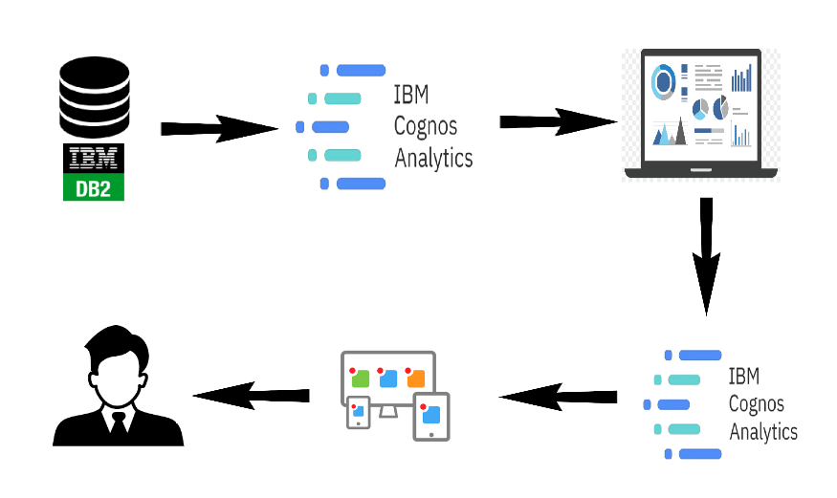The Deliverable shall include the architectural diagram as below and the information as per the table1 & table 2

**Table-1 : Components & Technologies:**

|  |  |  |  |
| --- | --- | --- | --- |
| **S.No** | **Component** | **Description** | **Technology** |
|  | User Interface | How user interacts with application e.g.  Web UI, Mobile App, Chatbot etc. | HTML, CSS, JavaScript / Angular Js / React Js etc. |
|  | Database | Data Type, Configurations etc. | MySQL, NoSQL, etc. |
|  | Cloud Database | Database Service on Cloud | IBM DB2, IBM Cloud etc. |
|  | Backend | Language used to implement backend | Python flask, rest API |
|  | Analysis | Analysing of the project done on | IBM cognos analytics |

**Table-2: Application Characteristics:**

| **S.No** | **Characteristics** | **Description** | **Technology** |
| --- | --- | --- | --- |
|  | Historical Trends | By analyzing the data from past Olympic games, we can identify patterns and trends in sports participation and performance. This can include which sports have been consistently popular over time, which countries have historically performed well in certain sports, and how certain events or rule changes have impacted participation and performance. | Cloud computing, visualization |
|  | Demographic Analysis | We can use data to understand the demographics of Olympic athletes, including factors such as age, gender, ethnicity, and socioeconomic background. This can help us identify patterns in participation and performance based on these factors, and can also inform discussions around equity and diversity in Olympic sports. | IBM Cognos Analytics |
|  | Performance Metrics | Data can be used to analyze specific performance metrics in Olympic sports, such as speed, accuracy, strength, and endurance. By examining these metrics, we can identify areas of strength and weakness for individual athletes and teams, and make predictions about future performance. | IBM Cloud, IBM Cognos |
|  | Economic Analysis | The economics of Olympic sports can also be analyzed using data, including factors such as the cost of equipment and facilities, sponsorship and advertising revenue, and the economic impact of hosting the Olympics in a particular city or country. By understanding the economic landscape of Olympic sports, we can better understand the forces that shape participation and performance. | IBM Cognos |

**References:**

[**https://c4model.com/**](https://c4model.com/)

[**https://developer.ibm.com/patterns/online-order-processing-system-during-pandemic/**](https://developer.ibm.com/patterns/online-order-processing-system-during-pandemic/)

[**https://www.ibm.com/cloud/architecture**](https://www.ibm.com/cloud/architecture)

[**https://aws.amazon.com/architecture**](https://aws.amazon.com/architecture)

[**https://medium.com/the-internal-startup/how-to-draw-useful-technical-architecture-diagrams-2d20c9fda90d**](https://medium.com/the-internal-startup/how-to-draw-useful-technical-architecture-diagrams-2d20c9fda90d)